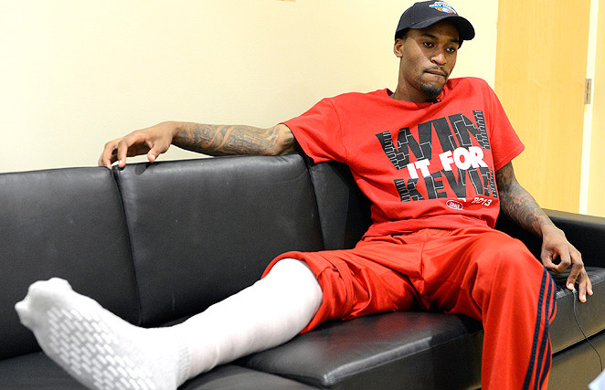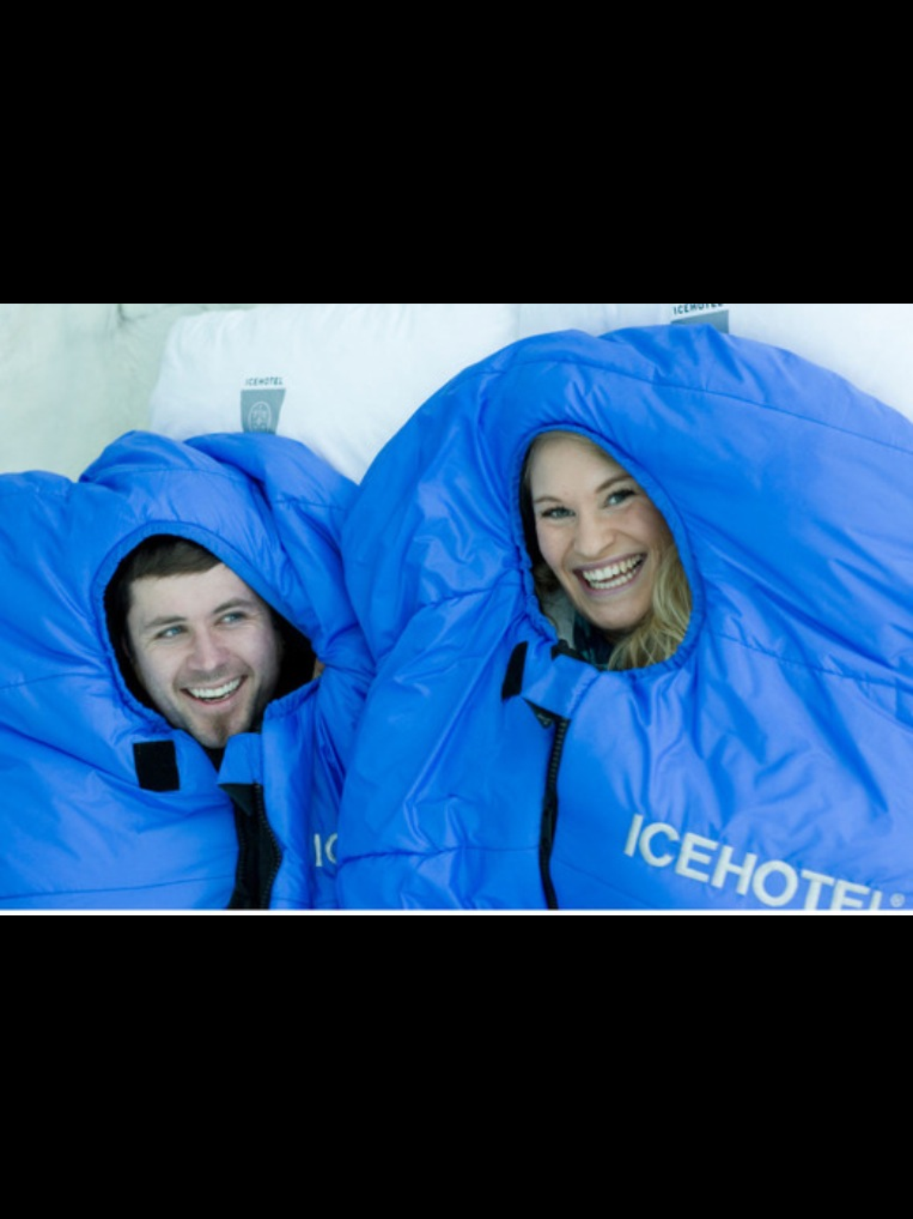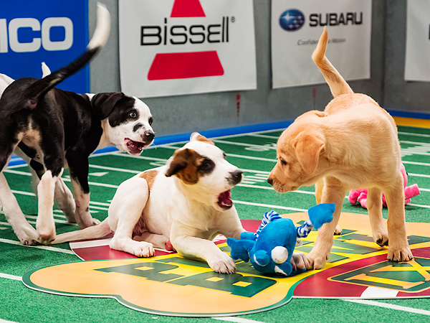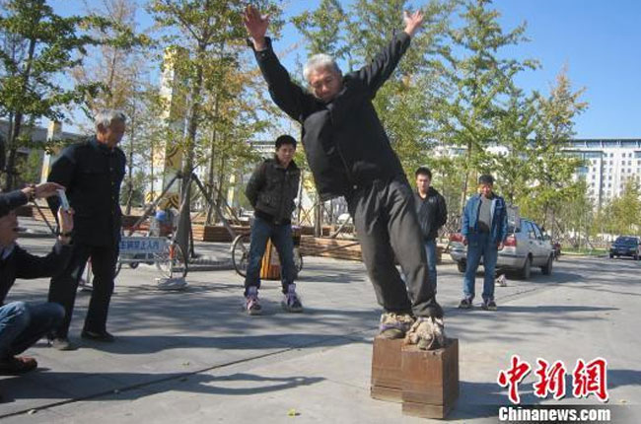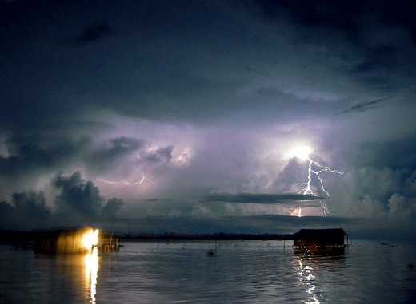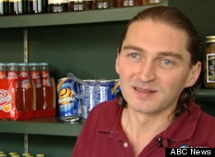

## Surfer Dogs!!! By: Desarea H.

# Ukraine Crisis By: Lorenzo and Avery

##### Things heat up in the Ukraine

What!?!!? It’s actually warmer in Alaska! You have got to be kidding me!

*Every year on June 4th dogs of all breeds, sizes, and shapes make their way to San Diego’s imperial beach for a fundraiser. The dogs also show how good they can surf. One time, over 50 dogs came to the beach to show how good they can hang.*

*The surf competition is pretty easy to understand. Each dog off of each team gets at least 10 minutes to catch 2 waves. In the competition, the judges usually look for attitude, cool surfboards, shorts, and cool shades. The contest is divided into two categories, dogs under 40lbs and dogs over 41lbs. Over 2000 people gather to watch this cool and fun event.*

*After a hard day at competing all of the dogs get to eat sausage and roast! After all, they did make a lot of money for charity! When the charity got the money everybody was happy!*

Ukraine's president Oleksandr Turchynov and other leaders of Ukraine tried to have a deal to hold early elections this year, put that didn’t calm the violence that was happening in the capital. Protester say, “it is not enough.” After that Turchynov resigned as the president of Ukraine and now Oleksandr Turchynov will lead Ukraine until elections are held on May 25, 2014.The government and the leaders of Ukraine live a wealthy life, but citizens of Ukraine struggle with money.

Most citizens are tired of leaders living the good life while they struggle just to meet ends meat.

Pursue a life filled with risks and joy!

Check out Grant’s article on the River of Fire. It’s an interesting article about lightning that hits the area often.

Did Kevin Ware ever play again? What is he doing now?

It’s possible to stay in an ice hotel? Where would you do that?

5

4

2

6

#### Key Features

#### In this issue…

### Issue 1, March 14th. 2014

The Fifth Grade News

## Altanta, Georgia Freaks Out Over 1.7 inches of Snow By: Delani R.

Pu

For over 50 years, the city of Atlanta Georgia hasn’t had any snow! Isn't that a shocker? But they were even more shocked when they got their portion of the nasty winter weather. The warm southern state of Georgia are used to their warm and sunny spot that they don't usually have to worry about the cold and getting frost on their windows of their homes but all that got switched around in January.

When all the commotion of the snow first started, everyone responded differently.  For example, all the students in one part of Georgia were still in school and since the majority of the community didn’t know how to drive on snow, all of the students were stuck at school!  Buses that were sent out to bring all the students home went into people's yards, ditches, and just kept on sliding.  Students that were stuck at the school ended up staying all night.  They had to sleep on mats scattered around on the floors on schools gyms and classrooms. The only way they got home was either their siblings came to pick them up or the older kids could of walked to

**WOW!! It's cold outside, right? Well have you ever thought about spending the night in a ice hotel? Well, if you want to find out if that is possible, I would take a visit to Sweden and go to the village with the name of Jukkasjarvi village. Trust me, it is awesome!! Now let me tell you some interesting facts!!**

**Did you know that this is the ice hotels 24th year of service? Wow, right? That is amazing. Well it's not just a place were you just sleep, you can also admire the beautiful detail. Also because the rooms are so cold they would recommend you sleep in one of there thermal sleeping bags because I don't think you want to try to fall asleep in 23* weather. Well you know how in lots of hotels you have the choice to lay around and watch tv or do activitys with family In your room. Well in the ice hotel you can do those things to cool right.**

**Did you know that there are many copycats to this hotel but this one is the biggest. The places you could go to see the other ice hotels or in Canada, Norway, Finland and romaina just to sat if I were you I would go to the one in Sweden. The reason I got this idea is because I always wanted to find out if there was a ice hotel. Now I want to know if you would want to go there.  So that's my story now go find your own story. Have fun your friend secoya!**

A couple trying to stay warm at the hotel.

###### Continued on page 5

## Burr! It’s an Ice Hotel By: Secoya R.

Believe it or not – The only reason that Raul built the Lego car was to encourage carmakers to think “outside of the box”.

Have you ever tried to build a Lego car? Well,you may have tried but wait until you read about this!

 On the 23rd of December, residents of Melbourne saw a very unusual sight. A car made out of almost all Legos, was cruising down the streets or Melbourne. The car was a stunning yellow and black and was made from 500,000 Legos.

 A 20-year-old student, Raul Oida, built the vehicle. It is big enough to fit 2 adults. The car is powered by 4 engines that are orbital. Each engine holds 256 pistons that run on air. WOW!!!! Also the car was entirely built from Legos!!!

From the steering wheel to the seats that are surprisingly uncomfortable, to the doors and even a transparent window screen!!This is AWESOME!!!!!

## An Air-Powered Lego Car? Really? By: Kelsey R.

Puppies battling it out on the field.

What if you hate the Super Bowl? What could you watch instead? I would suggest you watch the Puppy Bowl. It is a great  thing watch on Animal Planet. It is a terrific show where you can see your favorite animal do football related activities.

        I am here to tell you about what all happens and how the Puppy Bowl works. The Puppy Bowl is really puppies mimicking football. This is how the puppy's get a touchdown, the puppies are suppose to get a ball shaped toy into the end zone. The penalty's are called when a puppy is caught relieving its self. The timeout are called when the water bowl runs dry. Now don't get me started on the cheerleaders, they are so cute, they are penguins. Now the halftime performance got me it was a cat that can play the keyboard.

         If you want more information than look on the Internet. This is how many people watch the Puppy Bowl. In fact, the Puppy Bowl had over 5.58 million viewers. So keep it up by watching the Puppy Bowl in 2015.

## Instead of the Super Bowl Next Year By: Laine H.

The brutal hit that ended the championship match.

Anderson Silva was considered to be one of the top fighters in the UFC. He was paid thousands of dollars for each match that he fought until he recently snapped his leg on December 28, 2013 against Chris Weidman. No one is quite sure if the superstar will ever be the same.

Chris Weidman and Anderson Silva looked pretty even after the first round (Weidman barely won it according to the judges score cards). It wasn't until later in second round when Anderson Silva snapped his leg. His leg snapped when Chris Weidman lifted his knee to block Silva's kick. When Silva's shin hit Weidman, Silva's leg immediately fractured at a nauseating angle. That ended the fight immediately and Chris Weidman kept the belt.

     It will take between 3 months and 6 months for him to recover. Dr. Steven Sanders inserted an intramedullary rod into Anderson Silva's left tibia. He will remain in the hospital for a while. They are talking about Anderson Silva coming back to the UFC at the end of the year of 2014. After that injury, it got put in the worst sport injuries of 2013. He is 38 years old and probably faces a very long rehabilitation after he fractured his shin.

Zhang going for a walk in his iron shoes that weigh over 100 pounds!

Do you feel the need to exercise your legs all the time? Then why don't you ask Zhang Fuxing for a pair of Iron Shoes? Athletic people always feel the need to exercise in light shoes, which may be why you do it. But Zhang thinks you get more exercise wearing shoes, that weigh over 100 pounds!!!

Zhang would exercise for at least 20 minutes, and manages to walk several meters with Iron Soes. Can you believe it! He names his exercise the "waddle". He thinks the shoes have such good healing powers he started manufacturing them in a factory near his home. Each pair he sells goes from 22 to 136 pounds, and the prices are 90 to 238 dollars. He sold 10 pairs to his neighbors and most of his pairs online! I would like to exercise in the Iron Shoes. They sound like a good source of exercise.

Zhang got the idea from a commercial he watched several years ago, saying heavy footwear is better exercise. So with all of the manufacturing he has been doing, he has over 100 pairs sold. About every season he adds more iron. So far his iron shoes are 40 cm. tall, and they weigh 154 pounds each! I would only be able to lift less than 50 pounds each!!! I'm really impressed with this guy.

ARE YOU WILLING TO WEAR THE ALL NEW IRON SHOES?

## Anderson Silvia’s Big Blow Out! By: Avery S.

## The Shoes of Bulkiness By: Kaleb H.

Do you think your storms are bad? Try living In the northern part of the South American country of Venezuela. Starting around February 10, Lake Maracaibo will have about a 160 night lighting storm. In the lake, the area of the Catotumbo River or the "river of fire" has lighting hit it every night for about 160 nights straight.

The lightning can be different colors depending on the moisture in the air. If there is no or very little moisture the lighting will appear white while if there is a lot of moisture in the air the lightning will appear in different shades of red, orange, or even purple!

The storms have been occurring for centuries but scientists still don't know why it happens. Some scientists think it is because of its unusual wind and heat. Others think it's from the methane from nearby marshes. Locals just believe it's the "spirit of Catotumbo" lightning up the night sky.

The deadly lake is protected by the tall Andes Mountains on three sides. The fourth side is open to the Caribbean Sea which sends warm winds onto the lake. When the cold winds from the Andes Mountains and the warm winds from the Caribbean Sea meet they create thunderstorms which results in lightning. There are about 1.2 million lightning strikes a year, the most in the world. Each strike is from 100,000 amps to 400,000 amps. That's enough to light up every light bulb in South America. The lighting has been hitting the same area for thousands of years!

So many more things are unknown. A big mystery that confuses scientists and the locals is why the lightning sometimes stops for long periods of time. In 2010, the lights disappeared for around six weeks. That's the longest disappearance in 104 years. Some people think it is because of climate change. The good news is it's never disappeared that long since then!

# Venezuela’s River of Fire By: Grant S.

A mystery man has spent 130,000 dollars on tips. The people who receive the tips usually have a need like money for college or living expenses. Just think, what would you do with the amount of money? Well, this mystery man strongly  encourages people to do the same who have been as fortunate and I do too!!! What do you think? So since that amazing tipper came along there have been many reporting of others joining in the RIDE!

#### Will it catch on?

Did you know that when you go to a fancy restaurant that you need to tip the waiter or waitress that serves you your food? We'll I got some news about some very generous tippers that came along one day! You are probably saying, “What does that mean”? Well, I will tell you in a minute but now here's something to think about. Think about what you would do with 5000 dollars. Well, that’s exactly what one person got tipped!

Warmer in Alaska than MOST Central States

BY: Jack B.

In Alaska, the weather has done the exact opposite as the rest of the United States.  Alaska has been getting a blast of warm air traveling its way north from Hawaii. So far, they have recorded highs that are up to fifty-five degrees Fahrenheit. The air would be warmer but its the temperature of the warm air depletes about twenty degrees or more over the ocean then a lot more in Alaska to about 33 degrees.

       In Alaska and Canada the polar vortex is common. It usually happens every year

But it only reaches Alaska about every two or three years. Also it isn't as severe in Alaska as it is Canada. Also the polar vortex is just a low jet stream but it is also a little higher in Alaska so that also contributes to the loss of the temperature of the warm air reaching Alaska. The air isn't even warm enough to melt a considerable amount of the ice or snow there so that would mean no loss of any space made by the ice and snow in Alaska. These are also not very uncommon temperatures in Alaska's Spring.

      So Alaska is warmer than the forty-eight central states because in February our average temperature in Indiana has been around 20-30. This concludes why Alaska is warmer than the other central states. It is warmer than almost all of them. The only one warmer is Hawaii but that isn't  a central state.

### Tips

### By: Tyler D

Have you ever heard of a college basketball player having a 6 in. bone sticking out of his leg? Well I have know someone who's had that happened too and I'm pretty some of you know him too. That's right it was 6 foot 2 Louisville Cardinals player #5 Kevin Ware. Also the BIG question is will Kevin Ware EVER lace up his basketball shoes and get back on the court and play AGAIN.

Kevin Ware was an Internet Sensation. Everyone was hoping he would get better. Kevin said it was going to be hard to recover from his injury. Kevin Ware said he had a lot of mixed emotions. He said he felt shocked and he also said he didn't feel any pain right away. Kevin said and I quote "after I shot my 3 pointer my leg felt a little funny". He also said  "Then, I looked down at my leg and saw the 6 in. bone sticking out of my leg". But after they took Kevin to the hospital and they told him he would need surgery and if everything went well he could..... PLAY AGAIN!!!  Kevin was so grateful he could play again and so were the fans, coaches, and family.

You all know that Kevin Ware is now playing again. Also that his leg is all..... better. So now that you know about Kevin Ware and his injury and all he went through, you can actually watch him play for the Louisville Cardinals during March Madness.  GO LOUISVILLE CARDINAL'S!!!!!!!

Kevin Ware’s Injury

By: Isel V.

###### Continued from page 2

New Breakthrough in Human Cell Printing

By: Grant and Odin

Did you know that the world has made a international breakthrough? This breakthrough allows us to print human cell. This is so cool because doctors can actually print what your cells look like then see if there is anything that is on a cell that isn't supposed to be there. The printing was inspired by ancient Chinese wood blocks that were found that date back to about 2000 years ago!

Have you ever wanted to see exactly what your brain looks like in 3D? Well now you can! This new cell printing lets us make 3D brain cells. Although you can print these cells we can't arrange them exactly how they look in your body but the printed brain cells may be able to connect like they do in your brain. This cell printing technique can help us research cancer and help us find a solution. It can also help us develop new drugs. So this cell printing breakthrough can be good and bad.

The printing is very easy and cheap. To print the cells you only need a Petri dish, cells grown in the Petri dish and a silicone mold. The printing happens by pouring the liquid with cells grown in a Petri dish onto a silicone mold, similar to how the ancient Chinese poured ink note the wood block. Just like the ink, it flows and is drawn into a strategically placed hole. Then when the mold Is lifted the cells stay in the desired form, this is something that has never been possible before.



Will delivery drones be the future?

## The New, Advanced Deliver System By: Brittney M.

In December, the CEO of Amazon sent out a shock across the U.S. Ya know how when you order a package it takes about two to four days for you to receive it? Well, with the CEO's amazing technology, if you order an item that weighs less than five pounds you can get it in at least 30 minutes.

Anyway, you may be thinking, "man, these things sound cool." These "things" are called Amazon Drones. Don't be thinking this will be happening soon because even the CEO thinks they are a bit risky. Some things they don't know are how they won't injure people or what will  happen if the drones collide with each other. Other unsolved questions are how the little airplanes will handle different weather, or will people try to steal them, and will they have enough battery power to deliver within a radius of 20 miles? And there are many more questions to be answered.

Meanwhile, the CEO is confident that one day Amazon Prime Air will be a reality. Although some people aren't in on the drones, they do agree that the CEO, Jeff Bezos, can pull it off. For now, we'll just have to deal with the packages being delivered by truck.

Justin Bieber and Avalanna together before his concert in New York

A tragedy occurred on September 26th, 2012 when young Avalanna Routh (aka Mrs Bieber) died at such a young age. If you were wondering how she died she died from a rare cancer that she had been battling from when she was 18 months old. The cancer she died from was AT/RT. AT/RT affects the brain also AT/RT is a brain tumor usually diagnosed in the childhood. In the United States three children per 1,000,000 or around 30 new are diagnosed each year. As I told you she started battling at 18 months old.

Avalanna grew up in Boston where she was a only child.  She lived with her mom and dad in a nice home.  Avalanna was treated with medicine at the Dana Farber Cancer Institute. The doctors tried to treat her condition but she never saw great results. Avalanna stayed positive.  She even tweeted "had a great day with the hubby" pretending that her hubby was Justin Bieber. Avalanna even had a pretend wedding for the two; just Justin and her. She had a red,yellow, and purple bouquet of flowers and also had a cardboard cutout of Justin Bieber for the ceremony.  A banner hung that said, “Just married”

When Justin heard about this, he sent the family and Avalanna to New York where Justin and Avalanna played candy land and ate cupcakes. But sadly Avalanna died 7 months after this dream date.

## Remembering Avalanna Routh By: Madison H.