Pineapple-Orange Frozen Yogurt

1 c. low-fat vanilla yogurt
1 c. pineapple chunks, fresh or canned
½ c. orange juice

- Place yogurt & fruit in large plastic zip-top bag, flatten and freeze overnight.
- Next day, combine fruit/yogurt mixture with orange juice in food processor or blender and pulse until smooth.
- Serve immediately & enjoy!

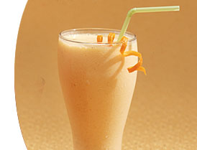

Used by permission of Purdue University Health & Human Sciences Department, Family Nutrition Program

